**Project 3**

**Integrate Grafana with a Linux Server for high CPU utilization and create a graph in Grafana.**

### Step 1 - Update and upgrade

sudo apt update -y && sudo apt upgrade -y

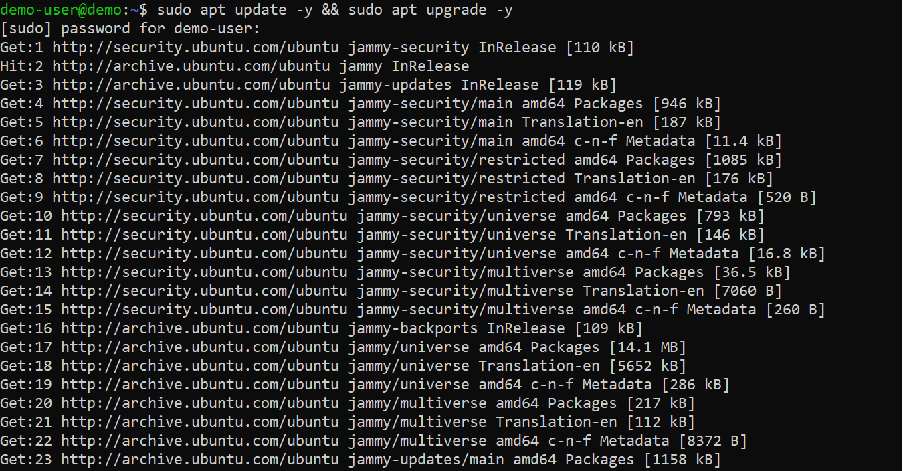

### [#](https://www.cherryservers.com/blog/install-grafana-ubuntu#step-2---install-the-required-packages)Step 2 - Install the required packages

Next, run the following command to install the packages needed for the installation:

sudo apt install -y apt-transport-https software-properties-common wget

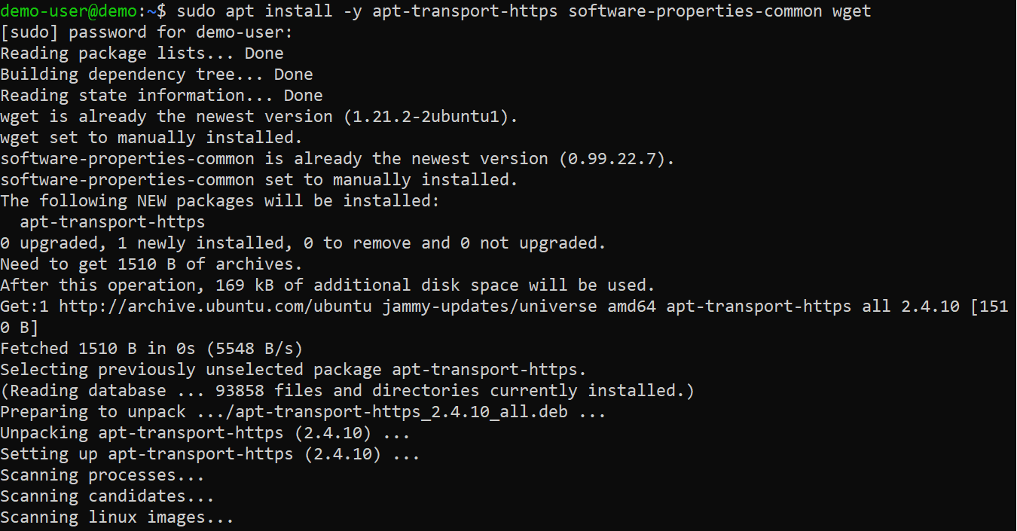

### [#](https://www.cherryservers.com/blog/install-grafana-ubuntu#step-3---add-the-grafana-gpg-key)Step 3 - Add the Grafana GPG key

sudo mkdir -p /etc/apt/keyrings/

wget -q -O - https://apt.grafana.com/gpg.key | gpg --dearmor | sudo tee /etc/apt/keyrings/grafana.gpg > /dev/null

The first command creates a directory where the key will be stored. The second command will download, convert, and store the key in the specified location for secure APT package management.

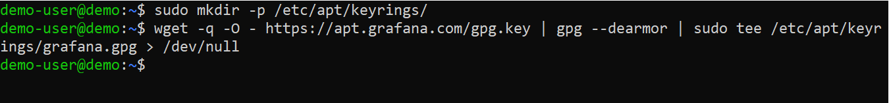

### [#](https://www.cherryservers.com/blog/install-grafana-ubuntu#step-4---add-grafana-apt-repository)Step 4 - Add Grafana APT repository

echo "deb [signed-by=/etc/apt/keyrings/grafana.gpg] https://apt.grafana.com stable main" | sudo tee -a /etc/apt/sources.list.d/grafana.list

After adding the repository to your system, update the package index to include information from the newly added repository using:

sudo apt update

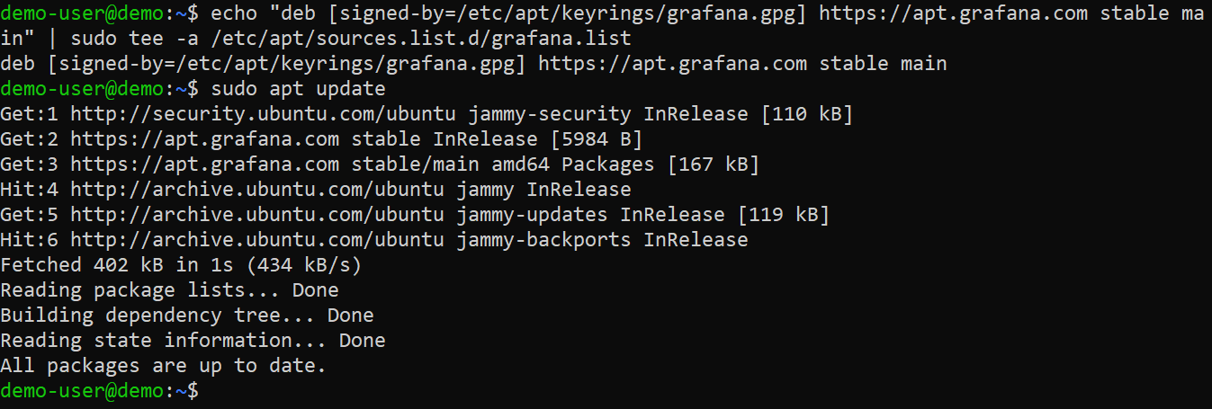

### [#](https://www.cherryservers.com/blog/install-grafana-ubuntu#step-5---install-grafana)Step 5 - Install Grafana

sudo apt install grafana

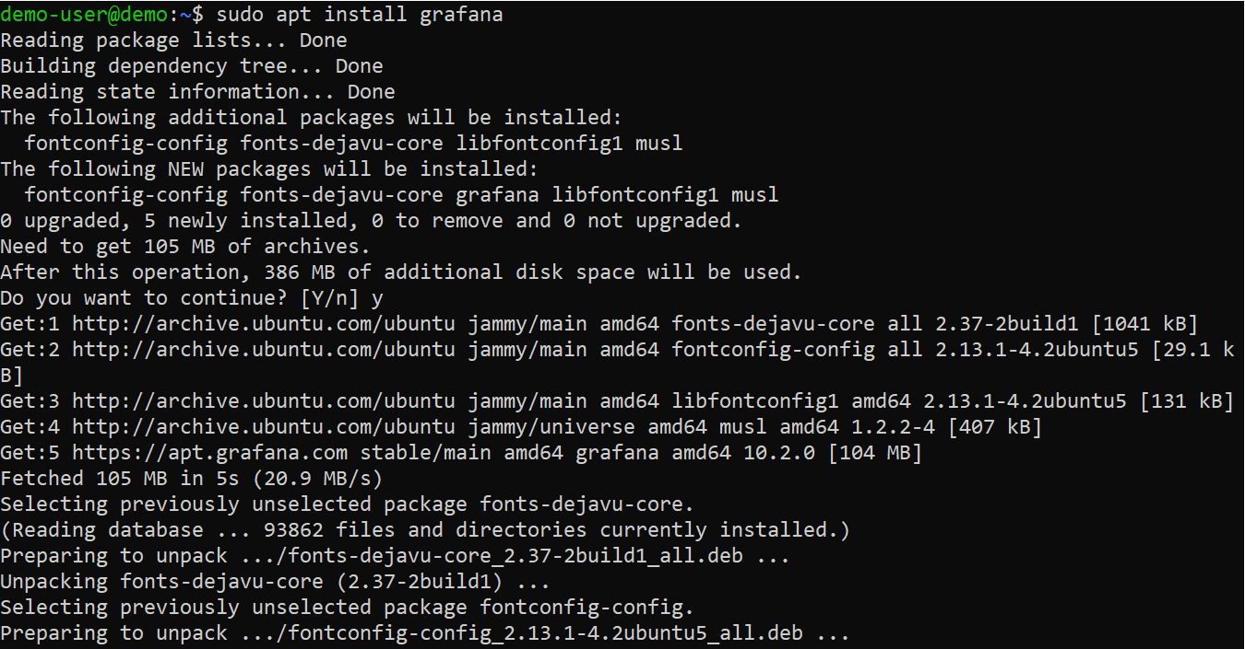

### [#](https://www.cherryservers.com/blog/install-grafana-ubuntu#step-6---start-the-grafana-service)Step 6 - Start the Grafana service

sudo grafana-server -v

Next, start the Grafana service and enable it to start automatically at system reboot using the following commands:

sudo systemctl start grafana-server

sudo systemctl enable grafana-server

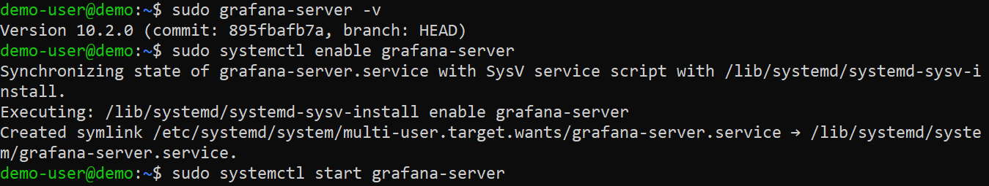

### [#](https://www.cherryservers.com/blog/install-grafana-ubuntu#step-7---verify-that-the-grafana-service-is-running)Step 7 - Verify that the Grafana service is running

sudo systemctl status grafana-server

If the Grafana service was started successfully, you should see a sign that it is active and running.

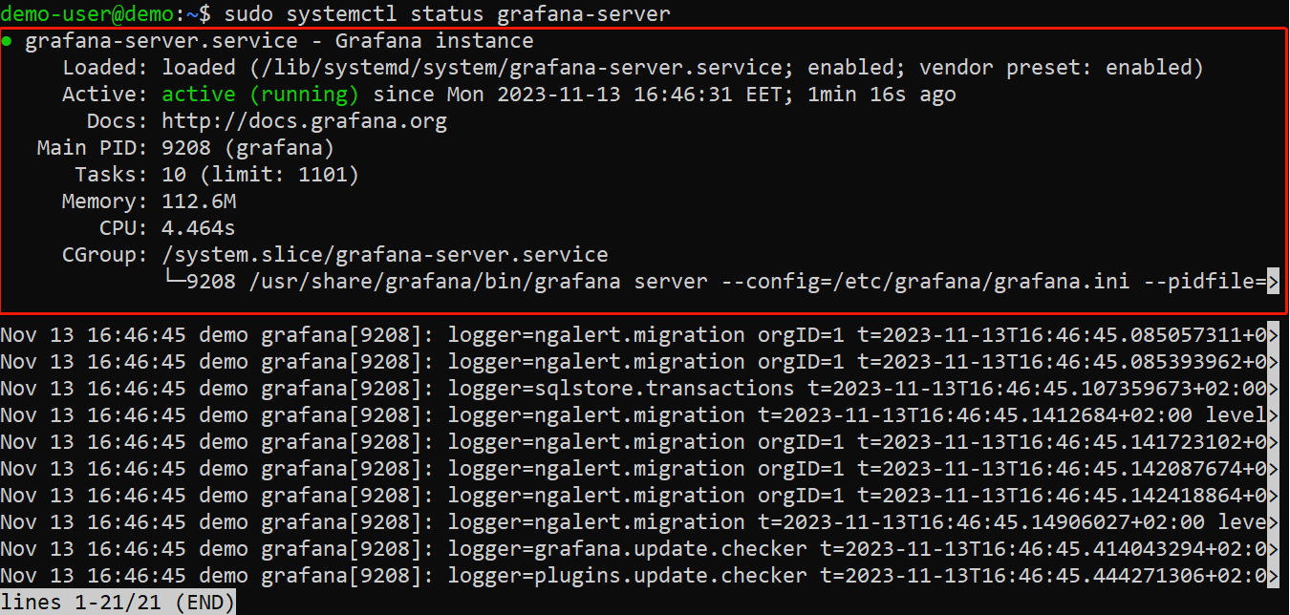

### [#](https://www.cherryservers.com/blog/install-grafana-ubuntu#step-8---open-the-port-in-the-firewall)Step 8 - Open the port in the firewall

sudo ufw enable

sudo ufw allow ssh

sudo ufw allow 3000/tcp

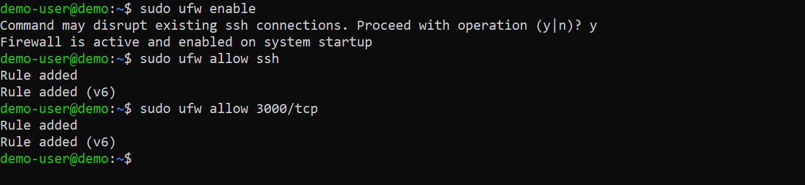

### [#](https://www.cherryservers.com/blog/install-grafana-ubuntu#step-9---access-the-grafana-web-interface)Step 9 - Access the Grafana web interface

To access the Grafana web interface, open a web browser and enter the IP address of your server (or hostname if applicable), followed by port 3000. The URL format should be http://your_server_IP:3000. Once loaded, you should see the Grafana login page. The default credentials are:

* **Username: admin**
* **Password: admin**

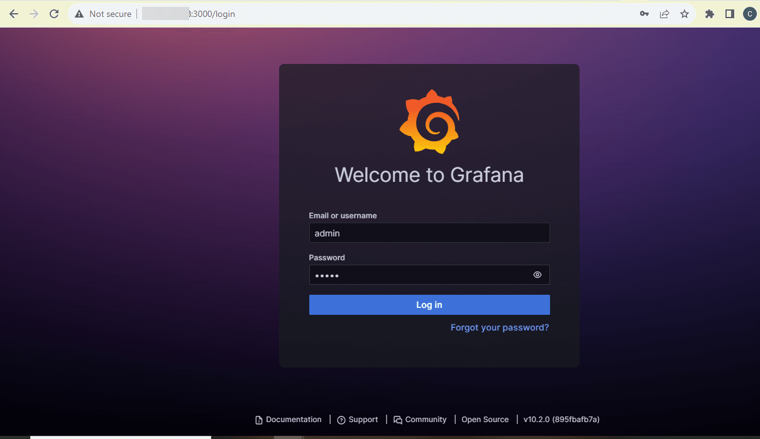

You'll be prompted to create a new password. Input a secure password, confirm it, and click the "Submit" button.

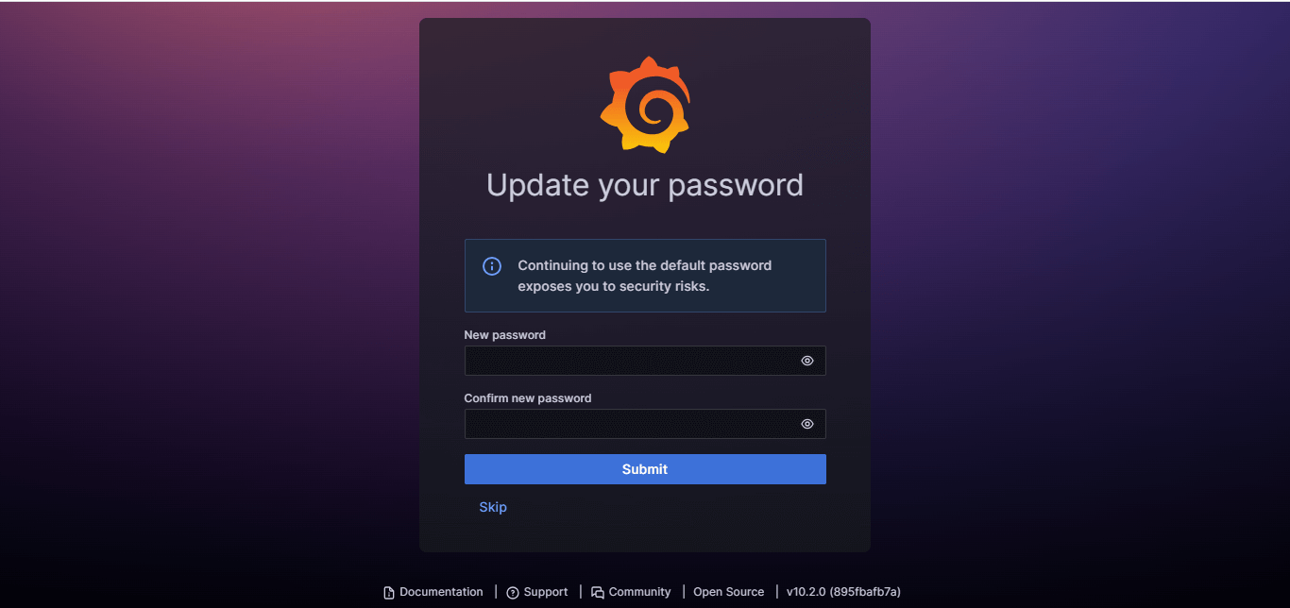

Once done, you'll have access to Grafana's dashboard.

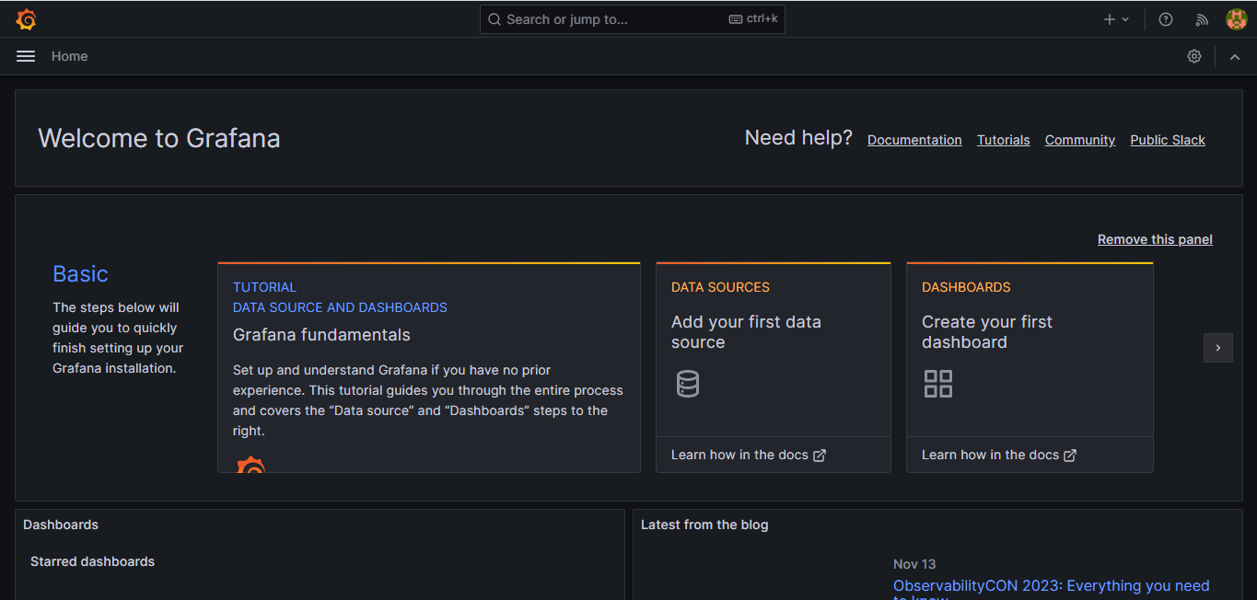

/

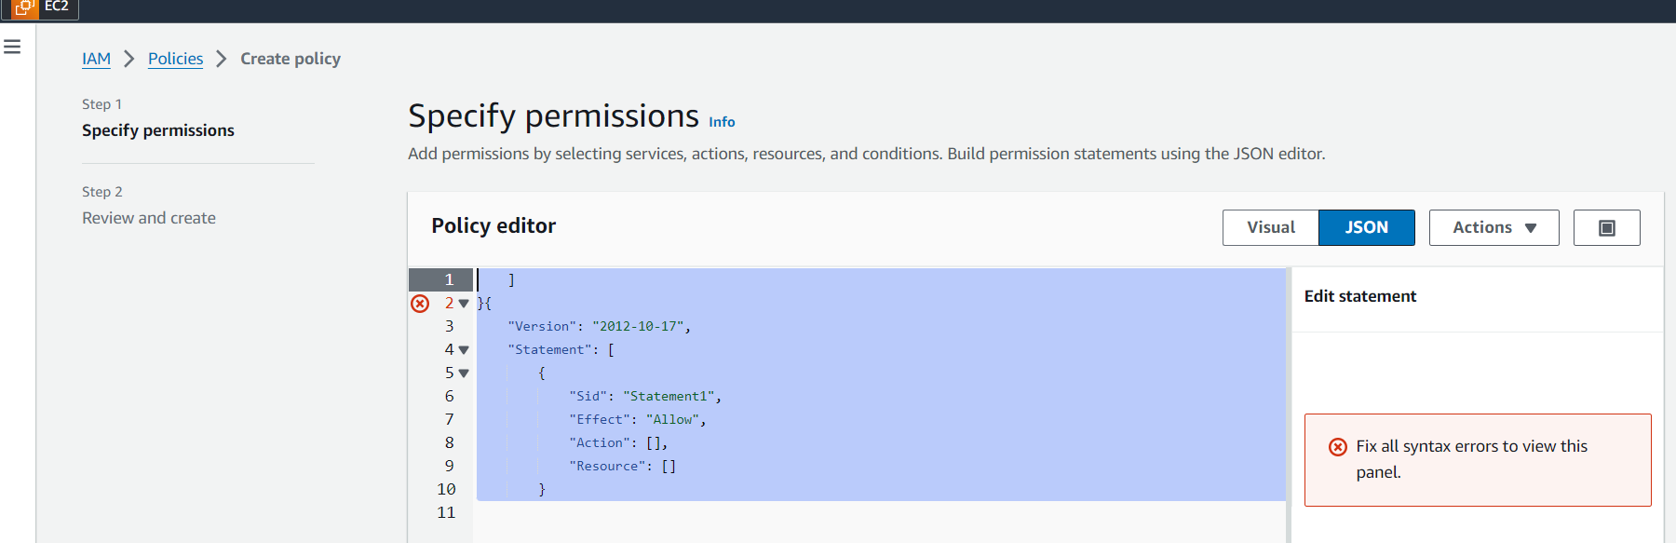Now open the AWS console and select the option IAM. first, Click on the **JSON** tab, Remove the existing code, and copy-paste the below policy statement into the editor:

Policy:

**{**

**"Version": "2012-10-17",**

**"Statement": [**

**{**

**"Sid": "VisualEditor0",**

**"Effect": "Allow",**

**"Action": [**

**"ec2:DescribeInstances",**

**"cloudwatch:GetMetricData",**

**"ec2:DescribeTags",**

**"ec2:DescribeRegions",**

**"cloudwatch:GetMetricStatistics",**

**"cloudwatch:ListMetrics"**

**],**

**"Resource": "*"**

**},**

**{**

**"Sid": "AllowReadingTagsInstancesRegionsFromEC2",**

**"Effect":"Allow",**

**"Action": ["ec2:DescribeTags","ec2:DescribeInstances","ec2:DescribeRegions"],**

**"Resource":"*"**

**},**

**{**

**"Sid": "AllowReadingResoucesForTags",**

**"Effect":"Allow",**

**"Action":"tag:GetResources",**

**"Resource":"*"**

**}**

**]**

**}**

Policy is created. Now click on the role tab. select the create role. Choose **Service or use case: EC2** click on the next. Select the policy and create a role. Your role is created-

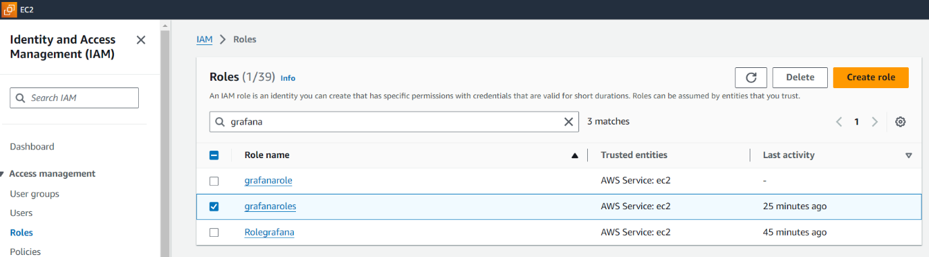

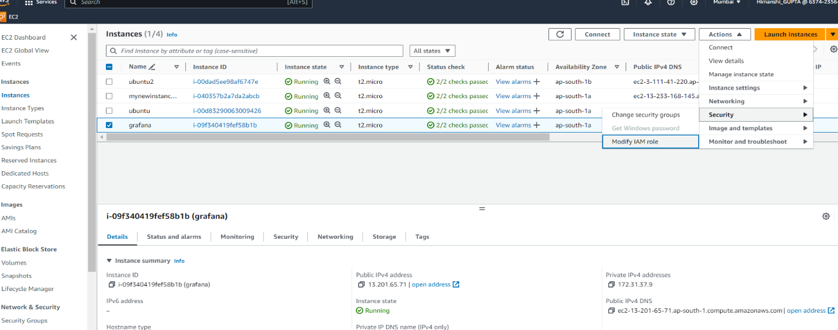Now go back to the Instances. Select your instance, click on the action tab, select the security, and then click on the Modify IAM role.

Select your role then click on update IAM role. now it’s done to see your graph.

Go back to the Grafana dashboard. click on the connection tab and select the data source option.

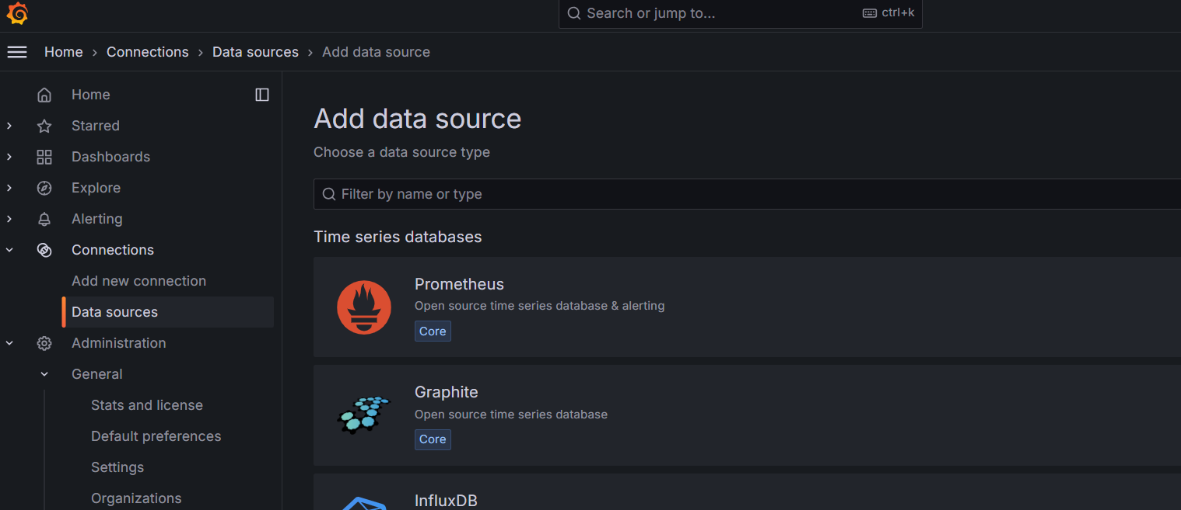

Select the cloud watch.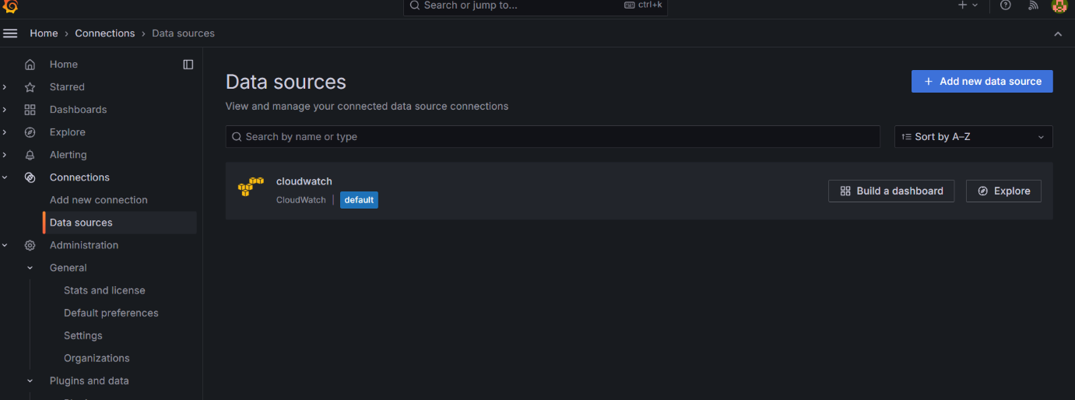

Check it in the Dashboard. You see your screen like that-

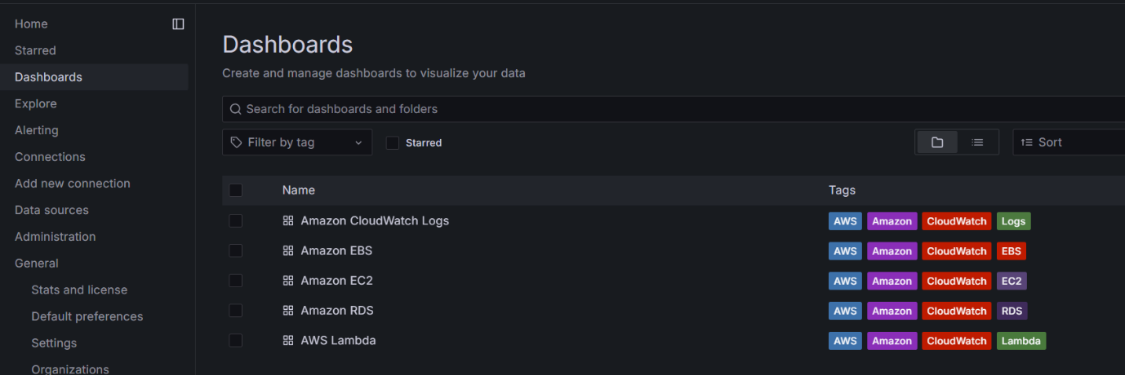

Click on the Amazon ec2 you see some errors.so click on the data source and change the region **ap-southeast-1** like that -

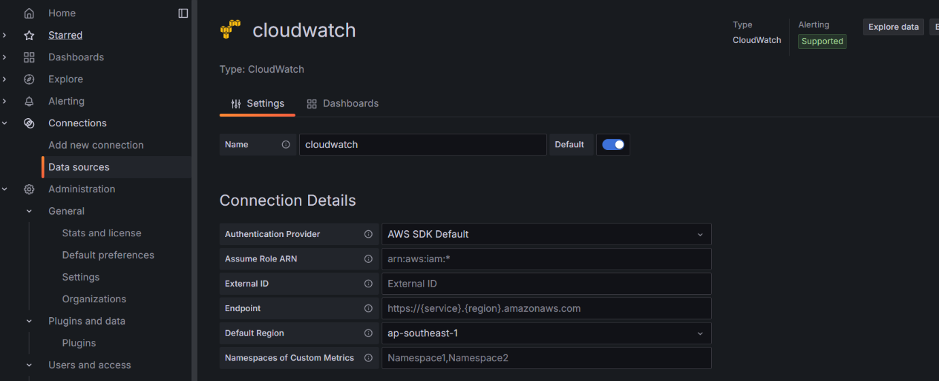

Save those changes.

Go back to the Dashboard now you see your Grafana graph.

